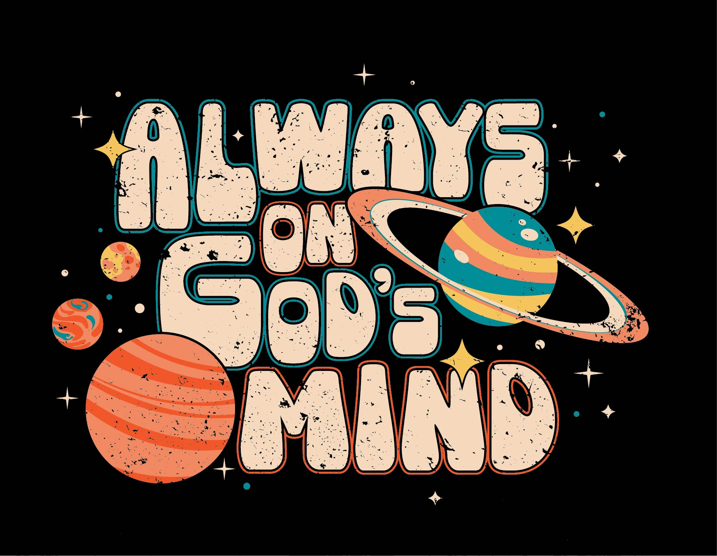

CHILDREN’S BIBLE STUDIES

Camp Theme Verse  Camp Theme Verse Introduction  No scheduled Bible Study on Sunday  Sunday: Creation Was on God’s Mind  Monday Bible Study:  I AM on God’s Mind  Tuesday Bible Study: Salvation was on God’s Mind  Wednesday Bible Study: The World is Still on God’s Mind | “How precious to me are your thoughts, God! How vase the sum of them! Were I to count them, they would outnumber the grains of sand-when I awake I am still with you.” (Psalm 139:17-18 NIV)  In Psalm 139, David shares with us God’s amazing characteristics. God knows everything about us, He knows our thoughts and our actions before we even do. God knows what we will say before we say it. God is everywhere. There is no place that we can go that God is not present. God created us in the womb in His unique image. He created us for a purpose. We are an example of His masterful work.  God our Creator thinks often and deeply about each of His children. We are constantly on His mind. God has a plan for each of us and cares for us. From the beginning, God cared for us. Even in our troubles, God’s thoughts are with us and carry us through every situation. God has a purpose for us, and we learn what it is as we read His Word. God’s Word reminds us of his love for us, his promises for us, and what He wants us to do for Him. The World is Always on God’s Mind.  Sunday: Creation Was on God’s Mind  Bible Study: God created everything there is.  Daily Memory Verse: Psalm 104:24 NIrV  Quiet Time: You are on God’s Mind  Monday: I Am on God’s Mind  Bible Study: All human life is sacred to God  Daily Memory Verse: Psalm 139:13-14 NIrV  Quiet Time: God Has Plans for You  Tuesday: Salvation was on God’s Mind  Bible Study: Salvation is only possible through Jesus  Daily Memory Verse: John 14:15 NIrV  Quiet Time: Who Was on Jesus’ Mind?  Wednesday: The World is Still on God’s Mind  Bible Study: God wants the gospel to be shared with all nations.  Daily Memory Verse: Matthew 28:19-20 NIrV  Quiet Time: Is the World on Your Mind?  Nathan Dorrell, our camp pastor, will share the Bible Study theme in the Sunday evening worship time. Group leaders do not need to prepare this lesson for Sunday. It is here for you to review and use as you choose - before camp, incorporate activities during the week, `or Sunday evening devotional.  Scripture: Genesis 1-2  Daily Memory Verse: “Lord, you have made so many things! How wise you were when you made all of them! The earth is full of your creatures.” (Psalm 104:24 NIrV)  Desired Outcomes: Campers will discover that God created the universe and everything in it. They will discover how people were always a part of God’s plan. Everything He made is good.  Bible Background: God with full purpose and intention made everything that exists. He created everything in the world from nothing. God’s creation is described day by day, and on the seventh day God rests from all His work. God created man and woman in His own image. We are special to God and He loves us more than we can understand.  Things to Gather:  - Camp Theme Verse Poster  - Memory Verse Poster 1  - Printable Item 1a (1 copy)  - Bible(s)  - Index Cards  - Printable Item 1b  Things to Do:  - Consider having today’s Bible study in an outdoor location.  - Make a copy of Printable Item 1a and cut boxes apart.  - Prepare index cards with Bible verse for memory verse challenge. Print one word of each verse on a card. Make multiple sets for multiple groups.  - Pray for God to lead you as you present His Word to students.  - Pray for the students who will hear God’s Word.  - Make a copy of Printable Item 1b and cut boxes apart.  Introductory Activity (5-10 Minutes):  - In this activity, students are encouraged to be outside, enjoying God’s creation. Take students outdoors on a short nature walk to observe all the unique beauty of God’s creation. (Consider having today’s lesson outside and have your nature walk conclude at the outside location for your Bible study.) As you are walking, ask students to observe and admire God’s creation around them.  - Give students some of the following examples to engage in as you walk:  - Watch for birds.  - Count how many different ones you see.  - Listen for animal sounds, such as dogs, cats, birds, cows, chickens, etc  - Compare the bark of different types of trees  - Search for an insect  - Find different shapes in the clouds  - Feel the wind and/or the sun  - Smell the flowers  - Examine different types of rocks  Bible Study (20 Minutes): (Consider staying outside for all of today’s Bible study)  - Introduce the story by asking students to close their eyes and tell you what they see. Allow students to respond and then say: “When I close my eyes, I can’t see anything - only darkness!” Ask campers to open their eyes.  - Say: “Genesis 1:2 tells us it was like this in the beginning. Before God created the trees, animals, the sun and the moon, everything was empty. There was nothing – nothing except for God. God is eternal.”  - Ask: “What does eternal mean?” Allow time for campers to respond. Then say: “It means that God has always been and will always be.”  - Arrange the number cards and creation items (Printable 1a). Separate the numbered cards from the items, so campers can match each day of creation to the things that God created on that day.  - Have students turn to Genesis 1 and follow along as you read. Pause after each day to allow campers to match up God’s creations to each day. With younger kids, it may be necessary to overemphasize, “It was Day one; It was day two,” etc.  - Read Genesis 2:1-3. Pause. Discuss how God rested on Day 7 from all the work of creating that he had done and discuss how it is important for us to also take time to rest.  - Continue by reading Genesis 2:4-25.  - Explain that God put Adam and Eve in the garden of Eden so they could live and take care of the things that God had created. God had planted a tree in the middle of the garden called the tree of the knowledge of good and evil, and told them that if they ate from that tree, they would die. God is eternal, which means He knows the beginning and the end and he didn’t want harm to come to Adam and Eve. Adam and Eve ate the fruit God commanded them not to. They disobeyed God, and sin entered the world. God is eternal and He made a plan to one day send Jesus to die for our sins so we could be in a relationship with Him forever.  Discussion Questions:  - What existed before creation?  - What did God create on each day?  - What happened when Adam and Eve disobeyed God? What did God do so we can be in a relationship with Him?  Bible Learning Activity (5 Minutes):  - Ask: How does God feel about creation? Say: Since God loves His creation, we should follow His example by loving the things that God made, which includes other people.  - Invite a volunteer to draw a “Caring for God’s Creation” card (Printable 1b) and pantomime the direction for the group. Let each camper draw a card and pantomime as time allows.  - Ask campers to share other ways they can care for God’s creation.  Memory Verse Challenge (10 Minutes):  Shuffle the cards and take turns putting the verse together in order. This can be done as a whole group, or create multiple sets of index cards and allow students to work in small groups.  Prayer (5 Minutes) :  - Look around the outdoors and remind campers of God’s creation.  - Ask campers to think of something that they could thank God for creating.  - Allow time for campers to pray and thank God for his creation, encourage campers who would like to pray out loud to do so.  - Model the following prayer and invite campers to pray silently and put it into their own words: God, thank you for my life. Thank you for loving me no matter what. Thank you for the sky and the fresh air to breathe. Please help us to make good use of our time during the day and to rest our bodies at night. We love you and thank you for all you do. Amen.  Scripture: Psalm 139:1-18  Daily Memory Verse: “You created the deepest parts of my being. You put me together inside my mother’s body. How you made me is amazing and wonderful. I praise you for that. What you have done is wonderful. I know that very well.” (Psalm 139:13-14 NIrV)  Desired Outcomes: Campers will discover that God has created each person in a unique way, that each person is important to Him, and that God has a plan for every individual He creates.  Bible Background: Psalm 139 tells that God is all-knowing, God is everywhere, and God is all-powerful. We are created by God. He creates us with a purpose. Everything God created is wonderful. God knows us better than we know ourselves. He knows our words before we speak them, and there is nothing about us that is hidden from God. God is always good. He loves us always and is always with us.  Things to Gather:  - Camp Theme Verse Poster  - Memory Verse Poster 2  - Printable Item 2a (3 copies)  - Printable Item 2b (1 copy)  - Bible(s)  - Rolling Pin  - playdough (all same color)  - Gingerbread Man cookie cutter  - Mirrors (enough for each student, like a compact travel mirror)  - Sharpies  - Tape  - Blank sheets of paper  - Water colored markers  Things to Do:  - Make sure every camper has a Bible.  - Make copies of Printable Item 2a and cut puzzle pieces apart, enough for each pair of campers.  - Make 1 copy of Printable Item 2b that you can display for all students to copy as needed.  - Pray for God to lead you as you present his word to campers.  - Pray for the campers who will hear God’s word.  Introductory Activity (5-10 Minutes):  - Ask campers to raise their hand if they have ever helped use a cookie cutter to make cookies.  - Take out playdough (make sure to use all the same color) and a rolling pin. Ask two volunteers to come up and roll out the dough until it is thin.  - Direct additional volunteers to use a gingerbread man cookie cutter to cut out the cookie shapes (use one cookie cutter so all cookies are the same).  - Remove the excess playdough and display all the gingerbread man cookies that have been cut out.  - Ask campers to look carefully at all the cookies while you ask the following questions:  - Are they all the same color?  - Are they all the same shape?  - Are they all the same size?  - What did we use to make sure they were identical?  - Direct campers to look at each other and think about the following questions:  - Is our hair all the same color?  - Do we all have the same eye color?  - Are we all the same size?  - Did God use a cookie cutter?  - Say: “No! Each of you is one of a kind - God’s special design!”  Bible Study (15 Minutes):  - Remind campers that yesterday we learned that creation was on God’s mind and that we were created in God’s image.  - Say: Today we will talk about how we are on God’s mind. We are fearfully and wonderfully created for a purpose. God made you just the way you are, and you are precious in His sight.  - Divide campers into three groups and have them read Psalm 139:1-18 with their groups.  - After campers have read, pass out a set of “The Greatness of God” puzzle pieces (Printable 2a) to each pair of campers and have them work together to match what each section shares about God’s greatest creation.  - Have campers share examples from these verses that show that “I am on God’s mind”.  - Remind campers that they are wonderfully made and created for a purpose.  - Say: It is great to have plans for our lives and our futures, but we must remember that God’s plans are best. If we pray for guidance and listen to His direction we will know our purpose.  Discussion Questions:  - Does God know you?  - How does it feel to know that God created you?  Bible Learning Activity (10 Minutes):  For Girls:  - Give each camper a mirror and permanent marker.  - Have them write an encouraging message (Printable 2b) on their mirror, so that whenever they look into it they remember they were created with a purpose by God and are wonderfully made. For example, students could write:  - I am Smart.  - You are Wonderfully Made.  - You are Created by God.  - You are Known by God.  For Boys:  - Ask campers to think of at least one compliment for each camper in the group.  - Tape a piece of paper onto each camper’s back. Give each camper a water-colored marker. Instruct campers to write a compliment on each camper’s back.  - After everyone has finished writing their compliments, help campers take their papers off their backs and read them.  - Ask campers to share a compliment they received. Ask: How do compliments make you feel?  - Say: We know from the story of creation that God thinks humans are “very good.” God thinks YOU are very good!  Memory Verse Challenge (10 Minutes):  - Display the memory verse poster and say the verse together several times.  - Direct a volunteer to come to the front of the room facing away from the verse.  - Have another volunteer point to one word from the verse so that the other campers can see, but not the first volunteer.  - The group then says the verse together, but claps on the selected word instead of saying it.  - The first volunteer should say which word was skipped. If the student gets stumped, let them look at the verse.  - Repeat with other volunteers.  Prayer (5 Minutes):  - Ask campers to think of something about themselves they are thankful for. Invite students who are willing to thank God for that thing. Give examples, such as “God, thank you for making me be a fast runner” or “God, thank you that I am a good listener.”  - Ask students who are willing to pray aloud thanking God.  - Close and say: Thank you for making us special in our own way. Amen.  Scripture: Luke 2:1-10; Luke 2:39-52; Mark 14:32-36  Daily Memory Verse: “If you love me, obey my commands.” (John 14:15 NIrV).  Desired Outcomes: Campers will discover that Jesus was God’s plan for the salvation of the world. They will understand how to be saved.  Bible Background:  Luke describes details about the birth of Jesus. While Mary and Joseph were in Bethlehem the time came for Jesus to be born. Mary wrapped Him in large strips of cloth and placed Him in a manger because there were no places for them to stay. Shepherds were taking care of their sheep nearby. They saw an angel of the Lord appear to them. The angel brought them good news of the birth of Jesus. (Luke 2:1-10).  Jesus grew up and became strong and very wise. When He was 12 years old, He stayed behind in Jerusalem when his parents left. When they noticed Jesus was missing, Mary and Joseph returned to Jerusalem to find Him sitting with the teachers, listening to them and asking questions. Everyone was amazed at how much He understood, including his parents. Jesus continued to grow, becoming wiser, stronger, and more pleasing to God and to people (Luke 2:39-52).  Many years later, when Jesus was grown, Jesus knew He was about to be arrested and crucified by the religious leaders. He went to a garden with his disciples. He was very sad. He prayed to God to take this suffering away from Him if it were possible, but even if it wasn’t He wanted to do what God wanted, not what He wanted. From the time He was born, Jesus was God’s plan for salvation. (Mark 14:32-36).  Things to Gather:  - Camp Theme Verse Poster  - Memory Verse Poster 3  - Printable 3a  - Paper, pencils, markers  Things to Do:  - Make sure every camper has a Bible.  - Copy Printable 3a  - Read over the memory verse and have movements or signs ready for each word.  - Pray for God to lead you as you present His Word and the plan of salvation to campers.  - Pray for students to respond to God’s Word.  - Trust God for the results. It is not up to you whether or not children respond to the Gospel.  Introductory Activity:  - “Follow the Leader” Game: Ask a volunteer to face the wall. Choose a camper to be the leader and make motions for everyone to follow. Leader changes motions discreetly. Ask the volunteer to turn around and try to guess the leader. After the leader has been guessed, choose another volunteer and leader.  - Ask: How did you figure out the leader?  - Say: In today’s Bible study, we’ll learn how Jesus followed God’s plan for Jesus to save us.  Bible Study (20 Minutes):  - Review the main ideas of the previous two days. Explain that today we are going to talk about how Salvation was on God’s mind. God had a plan from the beginning for Jesus to come and die for our sins so we could have eternal life with him.  - Divide campers into three groups and give each group one of the following scriptures to read together: Luke 2:1-10, Luke 2:39-52, Mark 14:32-36.  - Explain to campers that they will read the scriptures together and then create a skit about their part of the story of Jesus’ life to act out for the rest of the group.. Tell groups how long they have to work on their skits, no more than five minutes.  - Allow each group to perform their skit. After every group has gone, invite campers to share what they learned about the life of Jesus.  - Say: Jesus followed God’s plan for His life, wherever that led Him. He was able to live with all the temptation that we have, but He still did not sin. (Read Hebrews 4:15.) Jesus is a great example for us to follow in our lives.  - Say: We know from scripture that God loves each of us and that sin separates us from God. We know that everyone sins, but Jesus died for us.  - Divide into 3 groups and give each group one of the ABC printables (printable 3a). Each group will find and read the verses for their letter and can write notes on their poster. They will then share with the group what these verses say about becoming a Christian and having a relationship with Jesus.  Discussion Questions:  - What would have happened if Jesus had decided not to obey God, and die on the cross?  - What is it called when we don’t obey God and think or say things that don’t please God?  - How do we know what God wants us to do?  Bible Learning Activity (5 Minutes):  Divide into 3 groups and give each group one of the ABC printables (printable 3a). Each group will find and read the verses for their letter and can write notes on their poster. They will then share with the group what these verses say about becoming a Christian and having a relationship with Jesus.  Memory Verse Challenge (10 Minutes):  - Display memory verse poster and have campers stand up.  - Have campers come up with hand movements for each word in the memory verse. Practice saying and using hand movements to work on memorizing the verse.  - Allow individual campers who are willing to recite the verse with motions.  Prayer (5 Minutes):  - Say: When we know that we have sinned and believe that only Jesus can save us, then we can ask Him to forgive us of our sin, come into our heart and be our boss. That’s what the word “Lord” means. It means you give Jesus the authority to tell you what to do, and then you do it.  - Have campers spread out around the room. Invite campers to spend a few minutes praying. Instruct them to raise a hand when they have finished their time with God.  - Close in a time of prayer.  Scripture: Matthew 28:18-20; Acts 1:8  Daily Memory Verse: “So you must go and make disciples of all nations. Baptize them in the name of the Father and of the Son and of the Holy Spirit. Teach them to obey everything I have commanded you. And you can be sure that I am always with you, to the very end.” (Matthew 28:19-20 NIrV)  Desired Outcomes: Campers will discover God’s plan for telling the world about Jesus and their part in that plan; they will be able to identify ways they can tell others about Jesus.  Bible Background: Jesus commissioned his disciples, knowing that he would no longer be on earth as a man. Jesus needed His followers to do His work now. He commissions us today just like he commissioned his disciples. We are commissioned to share the gospel message with all people. We have been chosen by God to do His work and he is always with us and leading us while we do it.  Things to Gather:  - Camp Theme Verse Poster  - Memory Verse Poster 4  - Small treats (one for each camper)  - Gather 3 flying discs  - Printable Item 4a (1 of each)  Things to Do:  - Make sure every camper has a Bible.  - Make a copy of Printable 4a. Tape each page to a flying disc.  - Pray for God to lead you as you present his word to campers.  - Pray for the campers who will hear God’s word.  Introductory Activity (5-10 Minutes):  - Send two campers outside of the room with another adult leader to supervise.  - Give the other campers a small treat and say: God loves you!  - While they are enjoying their treat, tell them that there is also a treat for the campers who left the room and ask: How will the campers know about the treat and get the treat?  - Have campers give ideas and lead them to the conclusion that the only way to get the treat to the campers is to take it to them.  - Send one camper as the “Missionary” to deliver the treat and invite all three campers to return to the room.  - Explain that the camper would not have known about the treat if the Missionary had never gone to share.  - Say: Today we are going to talk about how God wants us to communicate for Him, and to whom He wants us to communicate.  Bible Study (20 Minutes):  - Remind campers that yesterday we talked about how Jesus was on God’s mind. We discussed the life of Jesus and how God had a plan from the beginning for Jesus to come and die for our sins so that we may have eternal life with him. He wants us, as children of God, to communicate this to others.  - Have campers turn to Matthew 28:18-20 and read aloud.  - Ask: What do these verses say we are to do in all nations? (make disciples, baptize them, teach them to obey)  - Say: To make disciples means that Jesus wants us to tell people about Him so that others can understand His love for them and how to become Christians. Being baptized is a way of showing those around you of your decision to follow Jesus. God wants us to learn and grow in our relationship to Him, He also wants us to teach new Christians in other nations to learn and grow in their relationship with Him. God wants us to be a light unto others and share His love with them by being an example of Jesus.  - Have campers turn to Acts 1:8 and read aloud.  - Say: Jesus names Jerusalem, Judea, and Samaria specifically in this verse because Jerusalem is where they were, Judea was a Roman province around Jerusalem, like our state and nation, and Samaria was in the same area, but the people there were from a different ethnic background that those in Jerusalem and not liked by the Jews. Samaria would represent the people in our state and nation who are culturally different from you.  - Say: Our mission field is not just overseas in a foreign country, it is in our own neighborhood and even in our own home.  - Break campers up into groups and give them one of the following mission fields. Have them discuss with their group how they could be an example of Jesus to others in these areas:  - Family member who is not a Christian  - School  - Soccer Field  - Dance Class  - Restaurant  - Vacation area that students are familiar with  - Foreign country that students are familiar with  - After campers have had time to discuss with their groups, have them share with the whole group.  - Remind campers that after you become a Christian, it is God’s desire for you to share Jesus with others who do not know him yet. You are chosen by God to do His work and He is always with us leading us while we do it through the Holy Spirit.  Discussion Questions:  - Was there a person in your life that pointed you toward Jesus?  - Has God laid anyone on your heart that he wants you to share His love with?  Bible Learning Activity (5 Minutes):  - Review the ABCs of Salvation with campers.  - Lead campers to form a circle. Explain that you will throw a disc to a camper (Disc A). They must explain what the letter means. That camper then throws the disc to someone else who explains the letter, and so on. Campers must remember who threw the disc to them and which camper they threw the disc to.  - After each camper has caught Disc A, throw Disc B to the first camper. That camper explains the letter on Disc B and throws the disc in sequence, with each camper explaining the letter on Disc B as they catch it.  - After everyone has caught Disc B, throw Disc C in the same sequence with each camper explaining the letter on Disc C.  - Now, pick up the pace. Throw Disc A in sequence, with campers explaining the letter. After a few campers have thrown Disc A, throw Disc B in sequence. Now throw Disc C. Campers should explain each letter as they catch the discs.  Memory Verse Challenge (10 Minutes):  - Direct campers to form 2 lines (A and B). Direct the 2 lines to face each other. Have one student on side A call out the first word of the memory verse, then the second word is called out by a student on side B. Students continue to call out each word but each side only calls out one word at a time as students continue to alternate through the remainder of the memory verse.  - After playing once or twice, call on volunteers to recite the whole memory verse from memory.  Prayer (5 Minutes):  - Say: God loves us very much and he wants to have a relationship with us. This gift of Jesus is not only for us but for everyone who believes in Jesus. God wants us to share Jesus with all the people who do not know Him yet.  - Close by allowing campers to pray silently for people in their lives who need to know about Jesus' love. Ask the Lord for courage to share Jesus' love.

